
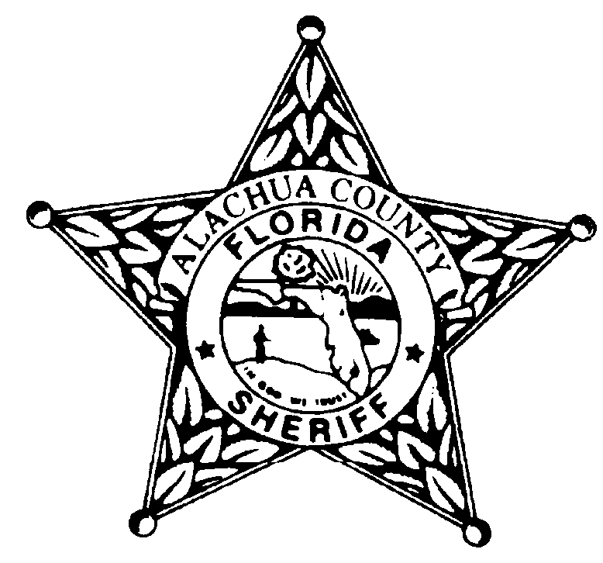
Alachua County Sheriff’s Office
November 2026

Jasmine Singleton, Teen Court Coordinator -352-367-4125 jsingleton@alachuasheriff.org
Zakiya Speed Teen Court Case Manager 352-367-4171 zspeed@alachuasheriff.org

Sunday | Monday | Tuesday | Wednesday | Thursday | Friday | Saturday
1 | 2 | 3  TEEN COURT/JURY DUTY  Criminal Justice Courthouse  4:00pm-7:00pm | 4 | 5 | 6  OFFICE CLOSED | 7
8 | 9 | 10  TEEN COURT/JURY DUTY  Criminal Justice Courthouse  4:00pm-7:00pm | 11 | 12 | 13  OFFICE CLOSED | 14
15 | 16 | 17  TEEN COURT/JURY DUTY  Criminal Justice Courthouse  4:00pm-7:00pm | 18 | 19 | 20  OFFICE CLOSED | 21
22 | 23 | 24  NO TEEN COURT | 25 | 26 | 27  OFFICE CLOSED | 28
Criminal Justice Courthouse: 220 South Main Street, Gainesville, FL 32601
ACSO: Alachua County Sheriff’s Office, 2621 SE Hawthorne Road, Gainesville, FL 32641
DOJ: Department of the Jail, 3333 NE 39th Avenue, Gainesville, FL 32609

