
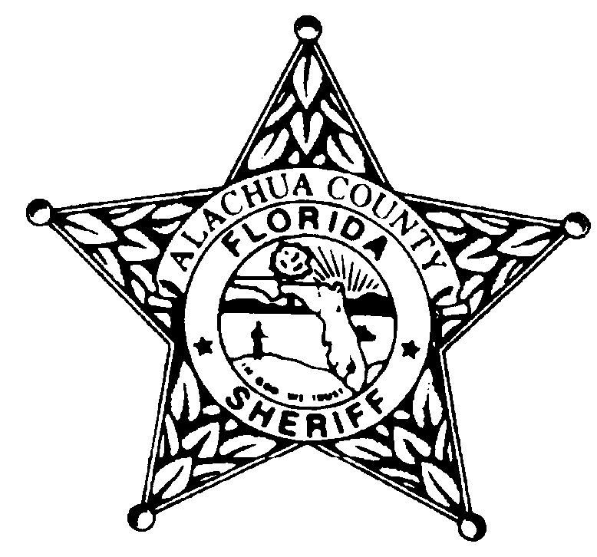
Alachua County Sheriff’s Office
November 2025
Olivia Hollier Teen Court Coordinator -352-367-4125 ohollier@alachuasheriff.org
Gregory Pelham Sr. Teen Court Case Manager 352-367-4121 gpelham@alachuasheriff.org
Zakiya Speed Teen Court Case Manager 352-367-4171 zspeed@alachuasheriff.org

Sunday | Monday | Tuesday | Wednesday | Thursday | Friday | Saturday
2 | 3 | 4  TEEN COURT/JURY DUTY  Criminal Justice Courthouse  4:00pm-7:00pm | 5 | 6 | 7  OFFICE CLOSED | 8
9 | 10 | 11  NO TEEN COURT  VETERANS DAY SBAC HOLIDAY | 12 | 13 | 14  OFFICE CLOSED | 15
16 | 17 | 18  TEEN COURT/JURY DUTY  Criminal Justice Courthouse  4:00pm-7:00pm | 19 | 20 | 21  OFFICE CLOSED | 22
23 | 24  THANKSGIVING HOLIDAYS | 25  NO TEEN COURT  THANKSGIVING HOLIDAYS | 26  THANKSGIVING HOLIDAYS | 27  THANKSGIVING HOLIDAYS | 28  OFFICE CLOSED  THANKSGIVING HOLIDAYS | 29
30 | 1 | 2  TEEN COURT/JURY DUTY  Criminal Justice Courthouse  4:00pm-7:00pm | 3 | 4 | 5  OFFICE CLOSED | 6
Criminal Justice Courthouse: 220 South Main Street, Gainesville, FL 32601
ACSO: Alachua County Sheriff’s Office, 2621 SE Hawthorne Road, Gainesville, FL 32641
DOJ: Department of the Jail, 3333 NE 39th Avenue, Gainesville, FL 32609
PACE: 1010 SE 4th Avenue, Gainesville, FL 32601, Contact Anthony Pierce- 352.374.8799

