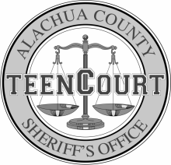
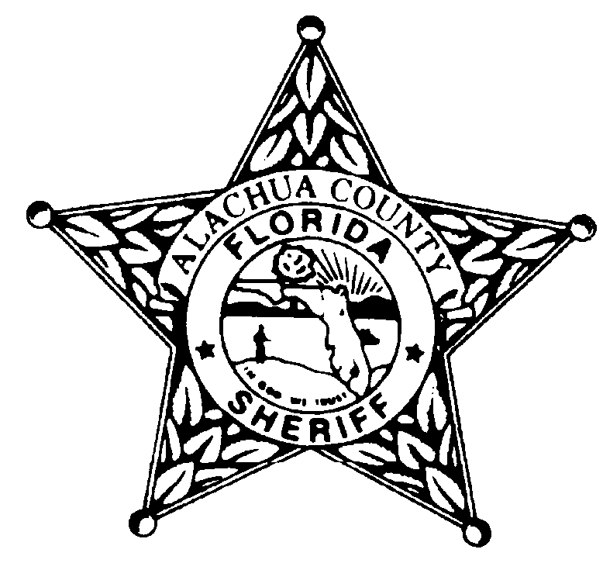
Alachua County Sheriff’s Office
December 2022
Olivia Hollier Teen Court Coordinator -352-367-4125 ohollier@alachuasheriff.org
Gregory Pelham Sr. Teen Court Case Manager 352-367-4121 gpelham@alachuasheriff.org
Sunday | Monday | Tuesday | Wednesday | Thursday | Friday | Saturday
27 | 28 | 29  TEEN COURT/JURY DUTY  Criminal Justice Courthouse  4:00pm-7:00pm | 30 | 1 | 2  OFFICE CLOSED | 3
4 | 5 | 6  TEEN COURT/JURY DUTY  Criminal Justice Courthouse  4:00pm-7:00pm | 7 | 8 | 9  OFFICE CLOSED | 10
11 | 12 | 13  TEEN COURT/JURY DUTY  Criminal Justice Courthouse  4:00pm-7:00pm | 14 | 15 | 16  OFFICE CLOSED | 17
18 | 19  NO SCHOOL SBAC | 20  NO TEEN COURT  NO SCHOOL SBAC | 21  NO SCHOOL SBAC | 22  NO SCHOOL SBAC | 23  OFFICE CLOSED  NO SCHOOL SBAC | 24
25 | 26  NO SCHOOL SBAC | 27  NO TEEN COURT  NO SCHOOL SBAC | 28  NO SCHOOL SBAC | 29  NO SCHOOL SBAC | 30  NO SCHOOL SBAC  OFFICE CLOSED | 31
Criminal Justice Courthouse: 220 South Main Street, Gainesville, FL 32601
ACSO: Alachua County Sheriff’s Office, 2621 SE Hawthorne Road, Gainesville, FL 32641
DOJ: Department of the Jail, 3333 NE 39th Avenue, Gainesville, FL 32609
PACE: 1010 SE 4th Avenue, Gainesville, FL 32601, Contact Anthony Pierce- 352.374.8799

